

2027

PHOTOGRAPHER REQUIREMENTS

FOR INTERNATIONAL ICE CLIMBING COMPETITIONS

ANNEX 6 OF UIAA EVENT ORGANIZER AGREEMENT (EOA)

GENERAL

Photographs provided to the UIAA will be used in articles and stories on the UIAA website and social media platforms to broadcast news about the 2027 UIAA Ice Climbing World Tour.

The composition of photographs will be a combination of human interest, editorial relevance, behind the scenes and competition action based on an agreed upon schedule, but with a certain amount of flexibility to account for breaking news – where warranted.
Three types of photographs are requested:
- News
- Marketing
- Artistic

Further specifics, including schedule and mode of delivery, are explained in detail hereafter.

All photographs provided to the UIAA will be considered free of restrictions for editorial use. When publishing photos and when possible, whether on its website or social platforms, the UIAA will add the credit ‘UIAA/name of photographer’.

PHOTOGRAPH QUALITY

The quality of photographs shall be for printing purposes (HD).

RIGHTS

The UIAA has the right to use photographs provided for its own editorial and marketing purposes. All images used for editorial purposes will be credited to the UIAA/name of photographer. Editorial images will be shared on the UIAA website, UIAA social media channels and made available to download in various resolution sizes on the UIAA Flickr Channel (or another photo sharing platform).

Photos on Flickr will bear the advisory. 'This photo is free of restrictions for editorial use only. The photo must be published with the full copyright information - UIAA/name of photographer'

The UIAA has the right to distribute images to news outlets for editorial purposes (with full credit), UIAA sponsors and non-commercial media outlets purely for promotion of UIAA Ice Climbing events.

As well as providing high-resolution images, the photographer has the right to provide the UIAA with a second set of images for UIAA social media which are watermarked. 'UIAA/name of photographer'. This is at the photographer’s discretion. If these images are provided the UIAA will upload these to its primary social media channels (Facebook, Instagram, X, etc). Otherwise, a watermark-free version will be used.

PHOTOGRAPHS: NEWS

OVERVIEW

The UIAA desires a variety of high-quality photographs which captures ‘behind the scenes’ content such as arrival of athletes, interesting profile shots, athlete interaction, preparation, warm-up, route planning as well as images of the crowd/spectators. The photographs from across the event especially those of athletes in competition should capture as many nations as possible during the event. This is especially important for the qualification rounds when all the athletes are active.

Quality is preferred over huge quantity. While good coverage is needed of all athletes and national teams and in fulfilling the brief, there is no need to supply multiple images of the same moment.

SPECIFICS

The UIAA desires high quality action photographs of both male and female climbers which capture the excitement of the competition ice climbing but preferably in the context of a narrative. These photographs will be used by the UIAA Communication team to promote the tour on multiple social media platforms and on the competition website.

Examples:

- Environment: At venues with natural ice, ice barrels or other ice features, it is important this are captured. The winter element of the competition is important for storytelling and these photos are more widely used.
- The leading athletes, legends, past winners
- Young Talents: Promising youth athletes who have shown the potential to compete at the highest level
- Surprise: A climber who, through the elimination rounds, has surprised with strong climbs and is a contender
- Dejection: A climber who has been eliminated early on despite being a lead contender
- Local athletes: Ensure at a given venue, some focus is given to athletes from the host nation
- Nationalities: Focus on providing images from as many nations as possible from the event.
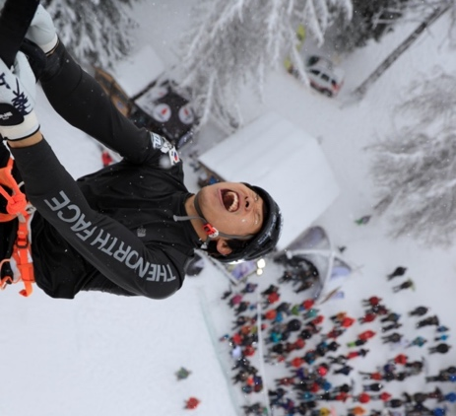
- The joy of winning

- They agony of defeat
- Audience interaction/
- Crowd scenes
- Sponsor branding (see section below)
- A sense of the venue/competition structure & wall (outside of competition as well_
- Finals:
  - Action
  - The moment of victory or defeat for a contender
  - Podiums. These are an essential deliverable. Photos from all podiums are required to fulfil sponsor and athlete obligations. All athletes on the podium should be visible and the photo should be centred on the gold medallist. Landscape mode preferred. However, please shoot wide enough to allow the image (or better the three athletes) to be cropped then in portrait mode for Instagram stories. See example:
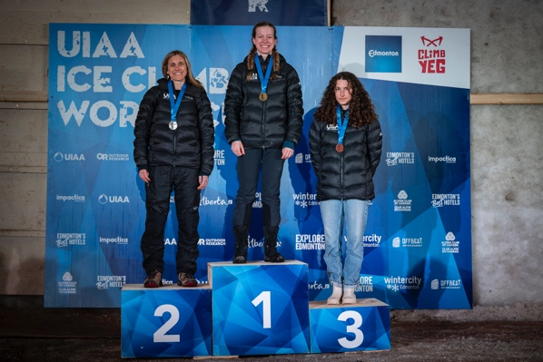
- The UIAA also requires a series of artistic shots which capture details and are a little more timeless. These may include:
  - Close ups of equipment – ice axes, holds, ropes
  - Close ups of athletes where the athlete is not as easy to identify, outstretched arm with an axe, crop of national team uniform
  - Close-ups of venue wall, structure, ice and winter conditions
  - Images of the people working on the event (media team, filming, technical officials, judges, etc).

SCHEDULE OF DELIVERY

The photographer should be prepared to attend a short briefing with the UIAA Event Coordinator before the competition starts at the photographer’s convenience. The photographer should contact the Event Coordinator – rob.adie@theuiaa.org – to arrange a time.

The photographer will send at least three (3) updates per day, ideally as soon as possible after each round of the competition, for the following three (3) to four (4) days:

- Arrival/Registration/Welcome Ceremony
- Day 1 of competition
- Day 2 of competition
- (Day 3 of competition where applicable)

A selection is required as soon as possible in order to provide assets for social media and immediate reporting.

Each of the respective days, the photographer shall send updates at the following moments:
- When competition starts; approximately 5 photos to get a sense of the scene.
- After each round of the competition; upload between 10 - 15 photographs for use on social media.
- End of competition; another 10 - 15 photographs within two hours after the prizegiving ceremony.

Note: On day of finals, the photographs should be uploaded or submitted as soon as possible.

In total, at least 100 images should be provided from each event.

MODE OF DELIVERY

The UIAA has revised its mode of delivery to ensure that all photographers can be accessed by the UIAA Communication team working in different locations.

Images should be uploaded to the following Dropbox link provided for each event

Photos should be organized by folder for each stage of competition, for example:
Saturday AM: Speed semi-finals, male
Sunday AM: Lead semi-finals, female

SAFETY & ATHLETE INTERACTION

SAFETY

All photographers granted media accreditation to take photographs at UIAA sanctioned events should have adequate safety equipment and training to be able to operate on and around the climbing structure to allow them to operate without endangering themselves, any of the athletes, UIAA officials and members of the public.

Photographers who climb on the structure to take their photographs do so at their own risk and should do so using the correct PPE equipment and techniques to make sure they keep all stakeholders involved in the event safe – this includes keeping ALL items of their photography equipment secured to their person at all times.

ATHLETE INTERACTION

Photographers should not obstruct the progress of athletes on the structure in any way, especially where they are in a position to get close to the athletes (depending on the design of certain UIAA event structures).

Photographers should not interact with the athletes in any way whilst they are in competition – no shouting, conveyance of information or encouragement should be passed to an athlete at any time.

PHOTOGRAPHS: MARKETING

OVERVIEW

The UIAA desires a variety of photographs which shows UIAA sponsors visibility on site.

SPECIFICS

The UIAA desires high quality photographs highlighting UIAA sponsors’ presence on site. This includes, but is not limited to:

- Photographs of the ice climbing structure with the sponsors’ banners (notably Fixe for the 2027 season)
- Photographs of athletes with the sponsors’ banner on the background

- Photographs of branding material from the sponsors

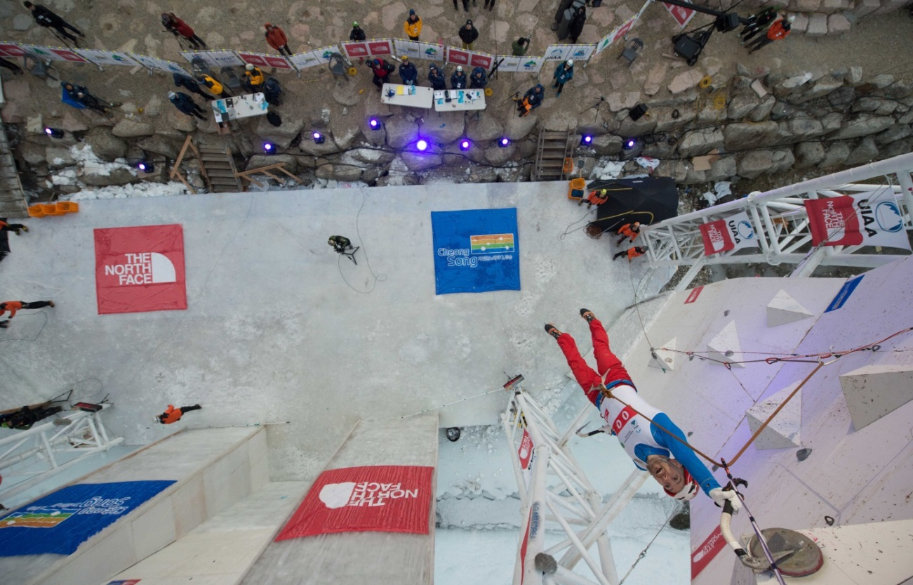

SCHEDULE OF DELIVERY

See above – section 2.3

MODE OF DELIVERY

The mode of delivery shall be coordinated between the UIAA Event Coordinator and the photographer prior to the competition. Possible options are:

- WeTransfer or similar file transfer site
- Email: Send photos to rob.adie@theuiaa.org and to news@theuiaa.org
- Dropbox: UIAA or photographer account or WeTransfer

All photos shall bear the following captions: Name of athlete, country, competition category (men’s/women’s and lead/speed) and the stage of the competition (qualification/semi-finals/ finals).

UIAA International Climbing and Mountaineering Federation
Monbijoustrasse 61 · Postfach · CH-3000 Bern 14 · Switzerland
+41 31 370 18 28 · www.theuiaa.org · office@theuiaa.org

